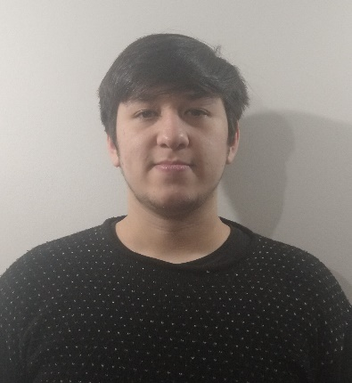6

PERSONAL PROFILE

Electronic Technician from “Instituto Tecnológico San Bonifacio” working as Systems Maintenance Technician at “Club Atlético San Lorenzo de Almagro”.I’m 19 years old and actively interested in programming at all its languages & levels, design & integral development of videogames and classic music among other things.

My current target is accumulating work experience and varied knowledge to one day apply it to the creation of a Videogame studio, in which to incorporate all the technical, logistical and artistic knowledge obtained and, in this way, create videogames that revolutionize the industry.

**Harry Martin**

Electronic Technician

**WORK EXPERIENCE**

2

**San Lorenzo de Almagro Athletic Club (2018-present)**

**System Maintenance Technician**

I am in charge of the maintenance and configuration of the access control systems to the Pedro Bidegain stadium, "The New Gasometer”, on match days

References: Alejandro Mayor – Systems Manager: Email: [amayor@sanlorenzo.com.ar](mailto:amayor@sanlorenzo.com.ar) Telephone: 11-5263-4600

**PERSONAL DATA**

Date of Birth

Name

Harry Martin

Civil Status

Single

Nationality

05/01/2001

**BOLSAPEL S.A. (2019-2019)**

Argentina



**CONTACT DATA**

I took care of the maintaining the machinery, partly mechanical and partly electronic, under the supervision of the maintenance team for about three months as an internship organized by my secondary school (Instituto Tecnológico San Bonifacio).

References: Víctor Maziel – Human Resources. Email: [vmaziel@bolsapel.com](mailto:vmaziel@bolsapel.com) Pablo Iaquinta – Professor in charge of the Internships organization Mobile Phone: +54116884-0219

**Maintenance Technician Internship**

**Higher technical degree in programming (2020-Present)**

Native

**Spanish**

**EDUCATION**

Immediately after finishing high school, I began my career as a Senior Technician in Programming at the UTN, since I understood that it would be the most appropriate career for the jobs I want to apply to, and every day I find it even more interesting, although not easy.

House of Studies: Universidad Técnica Nacional.

**English**

**LANGUAJES**

Advanced

harrymartin145wd@gmail.com

harrymartin145wd@hotmail.com

Phone

+54115346-3398

Email

Address

Blanco Encalada 1360, Temperley

8

**Electronic Technique (2012-2019)**

I studied in a technical / logical field since 2012 at the Technological Institute of San Bonifacio or "Sanbo", where knowledge and values ​​were instilled in me and more than anything, they guided me to form a logical way of thinking, which, added to knowledge, helps to overcome everyday problems seeing them from a much more methodical and effective angle. It also allowed me to forge the best friendships I have today.

House of Studies: Instituto Tecnológico San Bonifacio Proof of Title: <http://servicios.abc.gov.ar/servicios/buscadores/estados.de.titulos/?q=43182216>

**Musical interpretation on Violin**

**OTHER HOBBIES**

With 3 years of experience and having played in the Ezeiza Municipal Orchestra among others, I consider musical performance as a relaxing activity, capable of providing culture and uniting all those who participate in it.

Like most people of my generation, but even more, I love video games and music, I am also a huge fan of franchises like Star Wars and I really like Japanese animation and also reading, especially about science fiction.



**PRIVATE COURSES AND SELF-TAUGHT STUDIES**

**AAA 3D Game Design with Unreal Engine (2020-Present)**

I find myself learning through online videos about 3D Videogame design using the Unreal graphics Engine and the development environment that Unreal Editor provides for free.

Platform: Udemy.

8

**Cooperative Python Course (2018-Present)**

**Web Design with HTML5, CSS3 & JS (2018-Present)**

**Character Design in Pixel-art Style (2020-2020)**

**2D Game Developing with Unity (2020-Present)**

I firmly believe that the logical and methodical segregation of a problem allows it to be analyzed and resolved, regardless of its nature or magnitude.

**Methodism**

I am able to adapt to any necessary work area without fear of facing job challenges and assimilating new knowledge, even if it is beyond my area of ​​specification.

**Adaptability**

With experience in positions in which work was carried out as a team, I believe I am capable of working in a group of peers in which various opinions are used to reach a consensus about the best solution to any problem.

**Teamwork**

PERSONAL SKILLS

I joined a group to learn Python from 0 made by students in which we help each other with material and guide videos to learn this current and required language.

Platform: Cisco Academy, YouTube, Particular Material.

I am very interested in web layout as well as operations that run out of the user's view, in other words, Im interested in the Full-Stack. For this reason, I started with the basics of Front-End from various platforms and courses, and a lot of personal research.

Platform: YouTube, Kiko Palomares Academy, W3School.

I signed up for this course as a complementary course to 2D game development.

Platform: Domestica.

I am also learning about 2D game creation. after understanding the complexity and time involved in 3D game development I decided to take another path and start with something more viable as a first game project.

Platform: Domestica.